Section 1: Preparation

Network details

1. Devices:
1xDesktop, 1xLaptop, 1xWirelessRouter, 1xModem, 1xWebServer.
2. Type:
LAN (connected to a WAN).
3. Topology: Star.
On the network there are wired and radio types of transmission.

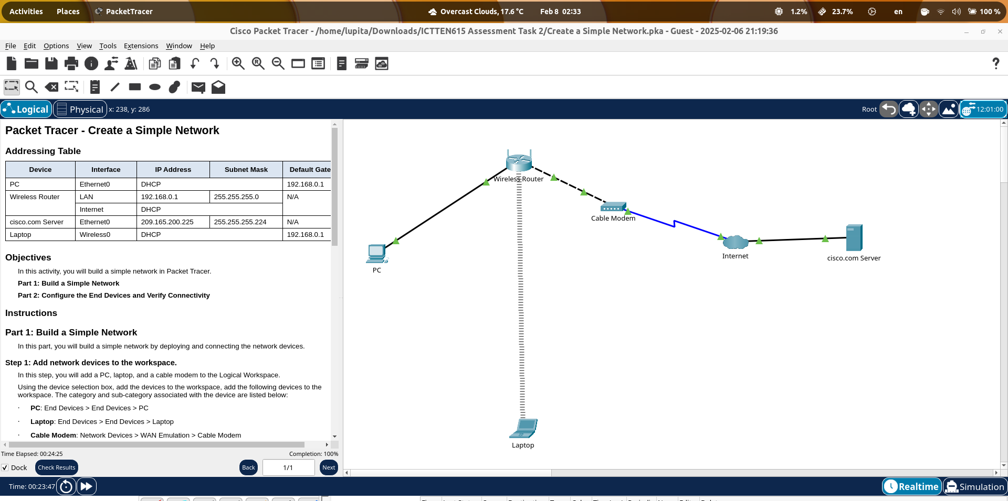
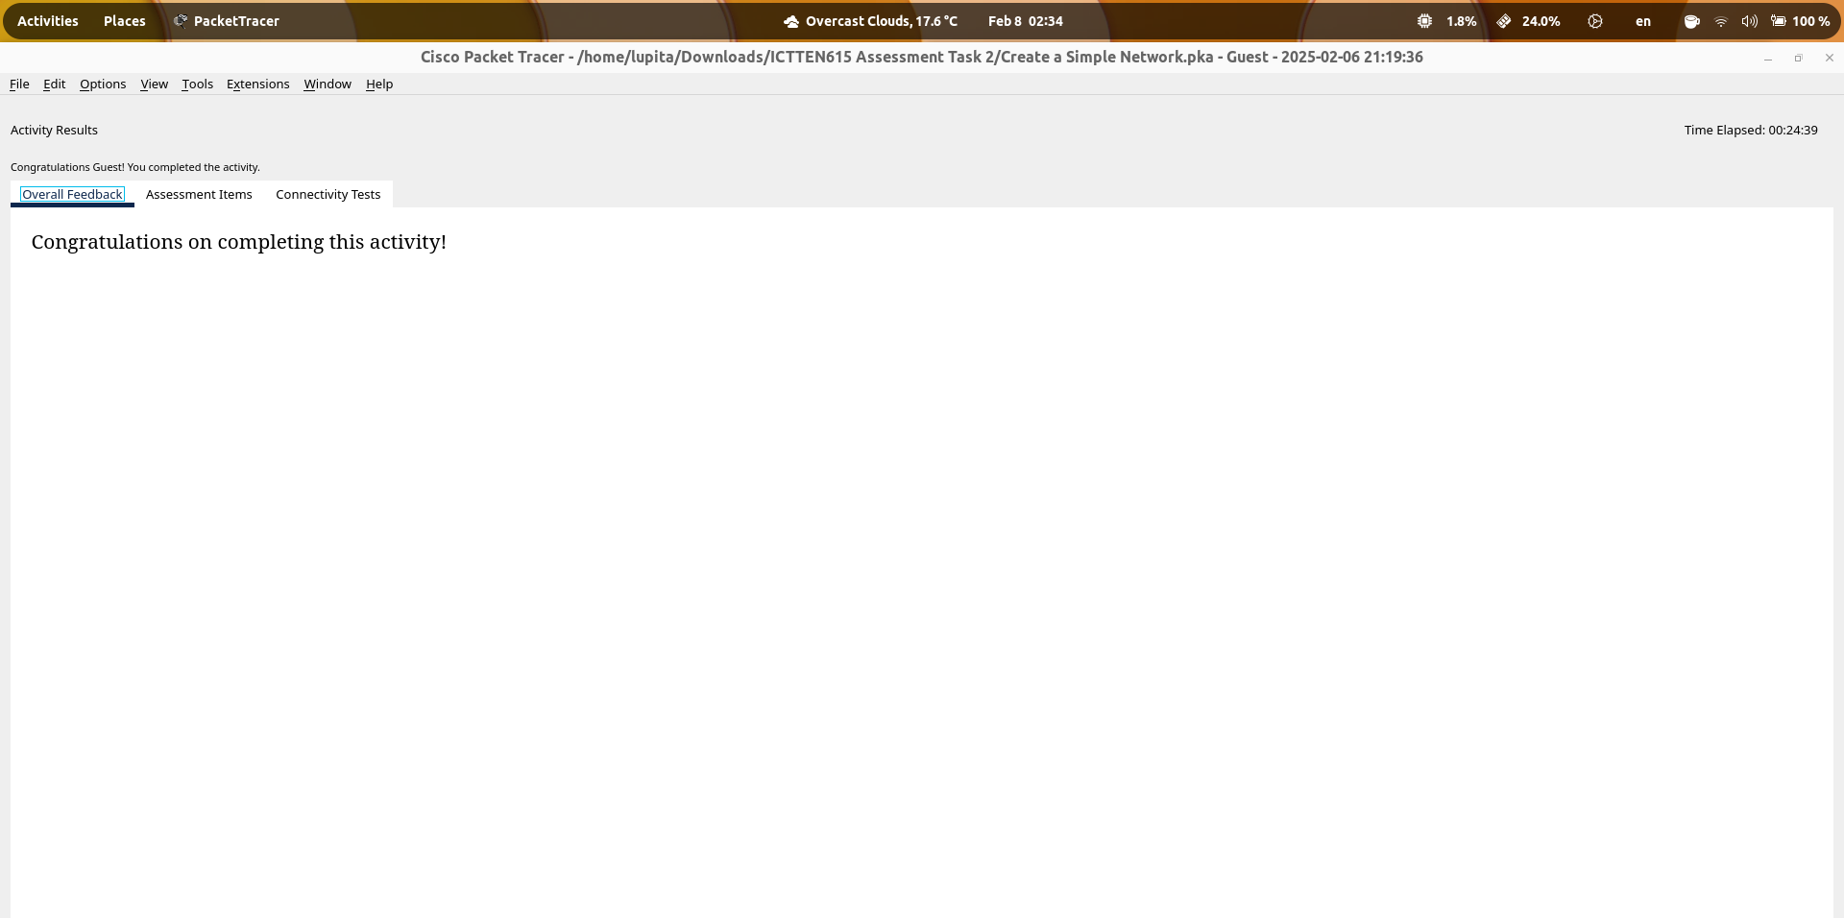

Work details

1. Scope of Work: TechCorp Solutions has a WLAN network that requires performance optimization. Employees use the network for daily operations including email, document storage, and shared access to applications.
2. Timelines: not defined
3. Procedures: Identifying traffic congestion and developing and implementing traffic control strategies to improving network performance.
4. Complaints: 1. Low internet speeds. 2. Delays in accessing cloud storage
5. Issues & problems: High network congestion (on peak business hours) due to excessive streaming and large file transfers
6. Planning network strategy: Reducing congestion by prioritising network traffic to cloud services. Also, Analyse network arquitecture and dimensioning to ensure that the traffic load will never approach a load of 100% on peak business hours.
7. Budget Allocated: not defined

Legislation, Codes, Regulations & Standards

1. Legislation: Australian Privacy Act 1988:
- I would take care about this legistaltion about data protection guidelines for protecting customers' personal information because the company share this information via email and cloud services and the information needs to be collected, used and accessed.

2. Codes: Payment Card Industry Data Security Standard (PCI DSS):
- Nowdays, credit card payments are very common, so in order to operate, this company must follow the PCI DSS, so I would use this code of conduct to store, process, or transmit credit card information.

3. Regulations: Australian Privacy Principles (APPs):
- Designed to protect the privacy of individuals. I would take care about this reuelation in order to ensure that the company operations follow transparent Management of Personal Information procedures.

4. Standards: ISO 27002:
- I would use this standard to align my work with international standards on data security best practices to keep confidentiality, integrity, and availability information company.

Network monitoring software

1. Wireshark

Network capacity and traffic congestion evaluation

networkctl status wlp1s0
Laptop IP: 192.168.1.100/24
laptop MAC: 70:a6:cc:72:00:0b
Network speed: 12 Mbps, 8 Mbps (1x10**6 bps)

1. Details of system alerts/alarms showing network issues.

- High Latency Alert: When latency is over 100ms
- Packet Loss Alert: When Packet loss is over 2%
- High Bandwidth Utilization: When network bandwith utilization is over 80%
- Unused Bandwidth : When network bandwith utilization is under 50% (peak hours)

2. Network traffic measurements.

Measures - Use of network:

No-peak hourse:
Packges loss rate: 0% (15s)
Bites loss rate: 0% (15s)
Bandwidth Utilization: 100% (250,000bps)

Peak hours:
Packges loss rate: 93% (100s)
Bites loss rate: 99% (100s)
Bandwidth Utilization: 0.25% (130bps)

- Details of traffic problems (potential or real):

In general, the connection to the server takes 10 times longer, and packet loss reaches 93%. It is important to note that bandwidth usage does not exceed 1%.

- Details of network outages (planned/unplanned):

In a server connection test it was detected that the network unplanned outages is frequent.

- Identifying network problems based on traffic measurement of all routes:

1. The packet loss rate is very high.
2. The bandwidth utilization is unused.

- Activation and de-activation of semi-permanent controls to simulate irregular traffic:

Throttling controls were used with the following settings:

1. GPRS connection
2. Regular 2G connection
3. Regular 3G connection
4. Regular 4G connection
5. Offline

Network analysis - Summary results
1. Network performance:

In general, devices do not use 100% of the network capacity.
During peak hours, network connection problems, bottleneck, latency and bandwidth underutilization are evident.

The following possible network issues were identified:
- Route and circuit availabilities
- System outages: The physical infrastructure is not adequate: cabling, routers, switches

2. Thresholds, loading and grading:
No-peak hours network behavior (Reference chart)

The grap show the typical network behaviour while a user is accessing to a web server on internet.

Packages rate:
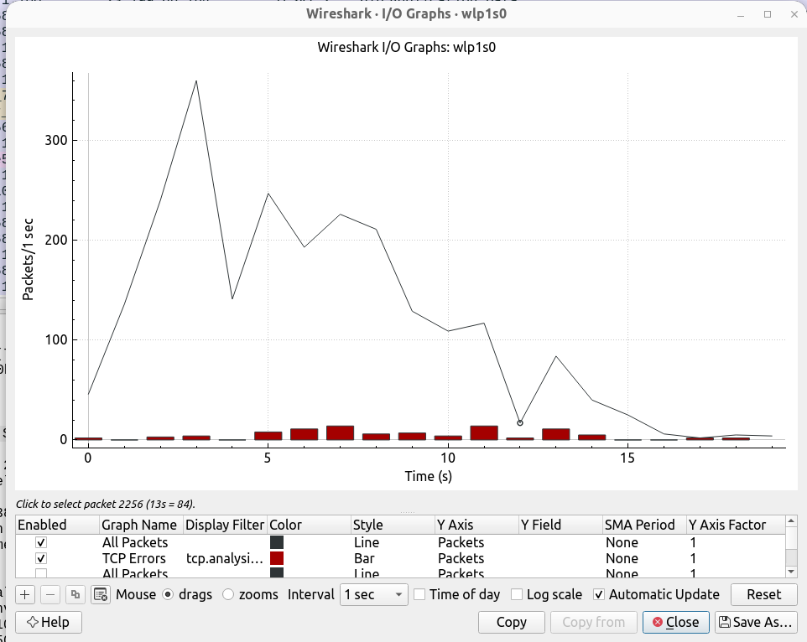

Bits rate:
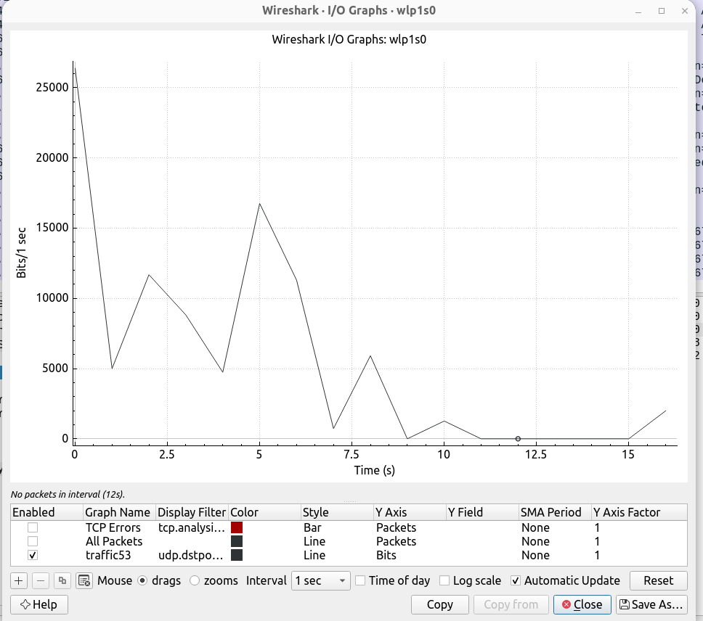

Peak hours Network behavior

Packages rate:
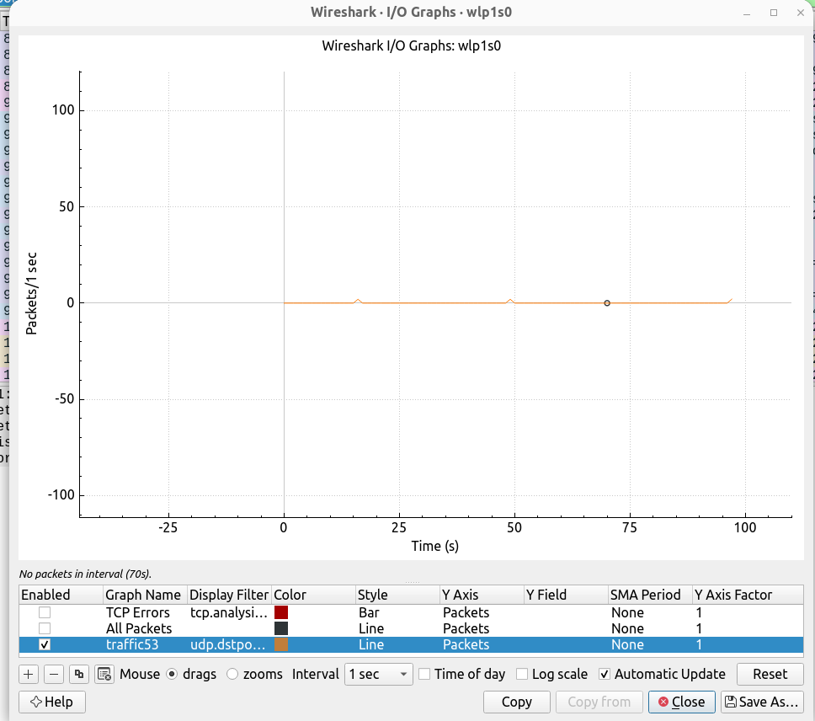

Bits rate:
